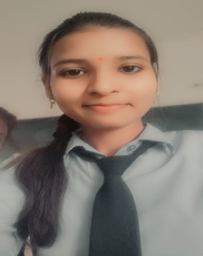 **RESUME**

Address: Makronia Sagar (M.P.)

Zip code: 470004

Contact No. : 6261128952

Email Id : ektapatel152001@gmail.com

**Ekta Patel**

**Career Objective**

To work in challenging and dynamic environment and to keep adding value to the organization that I represent and serve ,while also concurrently upgrading my skills and knowledge.

**Educational Qualification**

|  |  |  |  |  |
| --- | --- | --- | --- | --- |
| **Certificate/Degree** | **School/College** | **Board/University** | **Year of passing** | **Result** |
| B-Tech | Infinity Management and | RGPV University | 2023 |  |
|  |  |  |  |  |
|  |  |  |  |  |

**Technical Skills**

* **Computer language known :** C, C++ , Python.
* **Web Technologies :** HTML, CSS.
* **Operating System :** Windows 10
* **Database :** MySQL

**Personal Skills**

* Quick lerner.
* Hard working.
* Ability to deal with people politely.

**Personal Profile**

**Nationality :** Indian.

**Date of Birth:** 1st May 2001.

**Father’s Name:** Brijesh Patel.

**Mother’s Name:** Pushpa Patel.

**Language Known:** Hindi and English.

**Hobbies:** Sketching ,Listning Music, Surfing Internet.

I hereby declare that above information is correct to the best of my knowledge and belief.

**Date:**

**Place: Sagar**

**EKTA PATEL**

**Certificate/Degree School/College Board/University Year of passing Result**

B-Tech Infinity Management and RGPV University 2023

Engineering college

Higher Secondary Abhyuday Public school MP Board 2019 82.6%

Secondary Abhyuday Public school MP Board 2017 90.0%